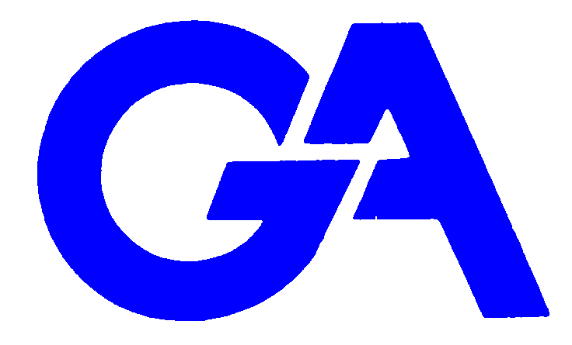

Modern Slavery Statement

The Modern Slavery Act 2015 sets out to ensure large organisations prevent modern slavery in their business and their supply chain. Whilst GA are not required by law to present an annual statement, we as a company wish to state that we are fully committed to preventing acts of modern slavery and human trafficking and as such will, wherever reasonable, fully cooperate with our larger clients’ systems and procedures which prevent modern slavery and human trafficking occurring.

Within our own organisation we ensure that all workers are paid above the minimum wage and are not subjected to excessive working hours or unsafe conditions. GA are committed to creating an established quality workforce and pride ourselves with our high percentage of worker retention which arises from loyalty based on values and mutual respect.

We endeavour to work only with companies who maintain our same ethos and expect transparency and openness in their practices as well.

Signed 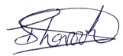

Director Date 02nd February 2018